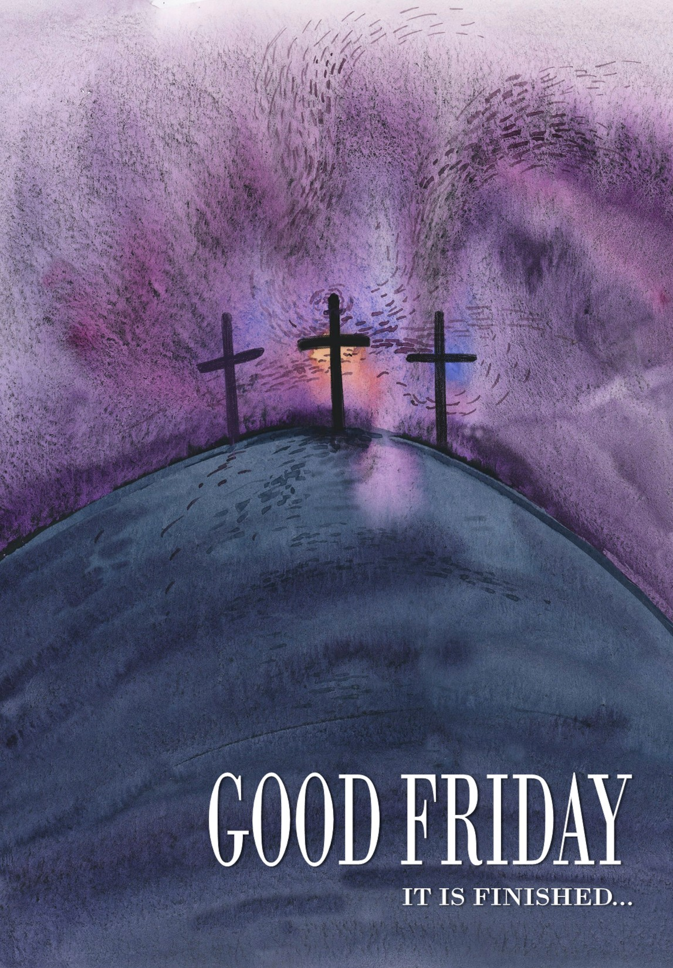
ASCENSION LUTHERAN CHURCH
GOOD FRIDAY – April 3, 2026
GOOD FRIDAY 2026

ORDER OF TENEBRAE
The Tenebrae Service is traditional in the Christian Church and is used during the last days of Holy Week to impress upon the hearts and minds of believers the awe-filled consequence of sin and the magnitude of the Savior’s sacrifice.
The word Tenebrae means “darkness.” It indicates the darkness which covered the earth at the time of Christ’s crucifixion. This darkness is visually portrayed in this service through the gradual extinguishing of the candles and other lights in the church.
The candles traditionally represent the disciples and other followers of our Lord. They gradually take to flight. The ensuing darkness symbolizes the growing resentment and hatred of the world toward the Lord Jesus Christ.
The Paschal candle symbolizes the Savior Himself. Near the end of the service it is removed from the candle-holder to symbolize the death of Jesus. The candle is not extinguished, but is carried from the chancel. (“A little while and ye shall not see Me.”) During the time the Paschal candle is removed, the silence is broken by a noise which symbolizes our participation in the crucifixion of our Lord. The Paschal candle is then returned to its place after “a little while” to remind us that Christ rose again.

LITURGY OF THE CROSS
Colossians 2:13-14 “And you, who were dead in your trespasses and the uncircumcision of your flesh, God made alive together with Him, having forgiven us all our trespasses, by canceling the record of debt that stood against us with its legal demands. This, He set aside, nailing it to the cross.”
If you find it meaningful, use a sheet of paper in the pew rack to write a personal sin, a stronghold of Satan in your life, a guilt that won’t go away, or a struggle that you want to give to God. Take the folded sheet with you, nailing it to the cross. No one will look at these sheets of paper. Pastor Jim will place them in a sealed envelope, and they will be destroyed after the service as a sign of our sins being nailed to the cross and buried. Again, this is optional. You may simply want to drive your nail into the cross using the words in your worship folder: “Lord Jesus, You were crucified for me. Lord, have mercy.”
PRE-SERVICE MUSIC

“Lenten Prayer”
Music by S. T. Nelson
Handbell Choir

“My Song Is Love Unknown”
J. Leavitt
Audrey Zeebuyth, violin

“Lead Me to Calvary”
Words by J.E. Hussey, Music by W.J. Kirkpatrick
Karon Keup, soloist

“Surely He Has Borne Our Griefs”
Music by L. Larson
Ascension Choir

Surely He has borne our griefs and carried our sorrows!
Surely He was wounded for us, bruised for our iniquities!
The chastisement of our peace fell upon Him, and with His stripes we are healed!
Like a lamb that is led to the slaughter, and yet He opened not His mouth!

Ah, holy Jesus, how have You offended,
That mortal judgment has on You descended?
By foes derided, by Your own rejected, O most afflicted!

WELCOME

INVOCATION

P In the name of the Father and of the T Son and of the Holy Spirit.
C Amen.

HYMN “O Dearest Jesus, What Law Have You Broken”

O dearest Jesus, what law have You broken
That such sharp sentence should on You be spoken?
Of what great crime have You to make confession,
What dark transgression?
READING Isaiah 52:13–15; 53:1–5a (ESV)
(He was pierced for our transgressions.)
¹³ Behold, My servant shall act wisely; He shall be high and lifted up, and shall be exalted. ¹⁴ As many were astonished at You—His appearance was so marred, beyond human semblance, and His form beyond that of the children of mankind—¹⁵ so shall He sprinkle many nations; kings shall shut their mouths because of Him; for that which has not been told them they see, and that which they have not heard they understand.
¹ Who has believed what he has heard from us? And to whom has the arm of the Lord been revealed? ² For He grew up before Him like a young plant, and like a root out of dry ground; He had no form or majesty that we should look at Him, and no beauty that we should desire Him. ³ He as despised and rejected by men; a Man of sorrows, and acquainted with grief; and as one from whom men hide their faces He was despised, and we esteemed Him not. ⁴ Surely He has borne our griefs and carried our sorrows; yet we esteemed Him stricken, smitten by God, and afflicted. ⁵ But He was pierced for our transgressions; He was crushed for our iniquities;

♫
They crown Your head with thorns,
They smite, they scourge You,
With cruel mockings to the cross they urge You;
They give You gall to drink, they still decry You;
They crucify You.

READING Isaiah 53:5b–6 (ESV)
upon Him was the chastisement that brought us peace, and with His wounds we are healed. ⁶ All we like sheep have gone astray; we have turned—every one—to his own way; and the Lord has laid on Him the iniquity of us all.

♫
What is the source of all Your mortal anguish?
It is my sins for which You, Lord, must languish;
Yes, all the wrath, the woe that You inherit,
This I do merit.

READING Isaiah 53:7–9 (ESV)
⁷ He was oppressed, and He was afflicted, yet He opened not His mouth; like a lamb that is led to the slaughter, and like a sheep that before its shearers is silent, so He opened not His mouth. ⁸ By oppression and judgment He was taken away; and as for His generation, who considered that He was cut off out of the land of the living, stricken for the transgression of My people? ⁹ And they made His grave with the wicked and with a rich man in His death, although He had done no violence, and there was no deceit in His mouth.

♫
How strange is this great paradox to ponder:
The shepherd dies for sheep who love to wander;
The master pays the debt His servants owe Him,
Who would not know Him.

READING Isaiah 53:10–12 (ESV)
¹⁰ Yet it was the will of the Lord to crush Him; He has put Him to grief; when His soul makes an offering for guilt, He shall see His offspring; He shall prolong His days; the will of the Lord shall prosper in His hand. ¹¹ Out of the anguish of His soul He shall see and be satisfied; by His knowledge shall the Righteous One, My Servant, make many to be accounted righteous, and He shall bear their iniquities. ¹²Therefore I will divide Him a portion with the many, and He shall divide the spoil with the strong, because He poured out His soul to death and was numbered with the transgressors; yet He bore the sin of many, and makes intercession for the transgressors.

♫
The sinless Son of God must die in sadness;
The sinful child of man may live in gladness;
We forfeited our lives yet are acquitted;
God is committed!

REFLECTION
P It is finished.
Stop and listen a moment.
Let the words wind through your heart.
Imagine the cry from the cross.
The sky is dark.
The other two victims are moaning.
Jeering mouths of the crowd are silent.
Perhaps there is thunder.
Perhaps there is weeping.
Perhaps there is silence.
Then Jesus draws in a deep breath, pushes His feet down on that Roman nail and cries, “It is finished!”
What was finished?
The history-long plan of redeeming man was finished.
The message of God to man was finished.
The works done by Jesus as a man on earth were finished.
The sting of death had been removed.
Jesus really died for you.
Jesus really died for me.

Confession and Absolution
P Lord our God, You took upon Your shoulders the weight of fallen humanity, becoming the sin offering for us so that we are made righteous in Your sight. Hear us as we bow before Your cross and lay our sins at Your feet.
In silent prayer, we bring the burdens of our sins to Jesus.
P Gracious Father,
C have mercy upon us. We are undeserving of Your love.
P Loving Lord Jesus,
C take our sins from us. Show us the depths of Your love, found only in the cross.
P Renewing Holy Spirit,
C Guide us and lead us. Enable us by faith to cling to the grace that alone can save. Amen.
P Almighty God in His great mercy has given His Son to die for you and, for His sake, He forgives you all your sins. Jesus bore our sins in His body on the cross so that we may die to sin and live in His righteousness. By His wounds, you have been healed. As a called and ordained servant of our crucified Savior, I forgive you all your sins in the name of the Father and of the T Son and of the Holy Spirit.
C Amen.

PRAYER
P Let us pray.
Almighty God, graciously behold this Your family for whom our Lord Jesus Christ was willing to be betrayed and delivered into the hands of sinful men to suffer death upon the cross; through the same Jesus Christ, Your Son, our Lord, who lives and reigns with You and the Holy Spirit, one God, now and forever.
C Amen.

HYMN “O Sacred Head, Now Wounded”
¹ O sacred Head, now wounded, with grief and shame weighed down,
Now scornfully surrounded with thorns, Thine only crown;
O sacred Head, what glory, what bliss, till now was Thine!
Yet, though despised and gory, I joy to call Thee mine.

³ What Thou, my Lord, hast suffered, was all for sinners’ gain;
Mine, mine was the transgression, but Thine the deadly pain.
Lo, here I fall, my Savior! ’Tis I deserve Thy place;
Look on me with Thy favor, And grant to me Thy grace.

⁵ What language shall I borrow to thank Thee, dearest Friend,
For this, Thy dying sorrow, Thy pity without end?
Oh, make me Thine forever, and should I fainting be,
Lord, let me never, never outlive my love for Thee.

LITURGY OF THE CROSS
At this time, you are invited to come forward to drive your nail into the cross. As you drive your nail you may softly speak these words: “Lord Jesus, You were crucified for me. Lord, have mercy.” It is also fitting to meditate on Psalms 22 and 31 during this time (see your pew Bible or hymnal).

MUSIC
“O Mighty Cross”
words and music by D. Baroni and J. Chisum
Carlyn Staudt, soloist

ADMONISHMENTS
P Thus says the Lord: “What have I done to you, O My people, and how have I offended you? Answer Me. For I have raised you up out of the prison house of sin and death, and you have delivered up your Redeemer to be scourged. For I have redeemed you from the house of bondage, and you have nailed your Savior to the cross. O My people.”
C Holy Lord God, holy and mighty God, holy and most merciful Redeemer; God eternal, do not allow us to die an eternal death. O Lord, have mercy.
P Thus says the Lord: “What have I done to you, O My people, and how have I offended you? Answer Me. For I have conquered all your foes, and you have delivered Me to those who persecute Me. For I have fed you with My Word and refreshed you with living water, and you have given Me gall and vinegar to drink. O My people.”
C Holy Lord God, holy and mighty God, holy and most merciful Redeemer; God eternal, allow us not to lose hope in the face of death and hell. O Lord, have mercy.
P Thus says the Lord: “What have I done to you, O My people, and how have I offended you? Answer Me. What more could have been done for My vineyard than I have done for it? When I looked for good grapes, why did it yield only bad? My people, is this how you thank your God? O My people.”
C Holy Lord God, holy and mighty God, holy and most merciful Redeemer; God eternal, keep us steadfast in the true faith. O Lord, have mercy.
LORD’S PRAYER
C Our Father, Who art in Heaven, hallowed be Thy name, Thy Kingdom come, Thy will be done on earth as it is in Heaven. Give us this day our daily bread; and forgive us our trespasses as we forgive those who trespass against us; and lead us not into temptation, but deliver us from evil. For Thine is the Kingdom and the power and the glory, forever and ever. Amen.

MUSIC “Hast Thou Forsaken Me?”
Words and music by Nottingham
Bruce Blubaum, soloist

READING John 19:19–22
(The King of the Jews.)
(The first candle is extinguished.)

READING John 19:23–24
(They divide His garments.)
(The second candle is extinguished.)

READING John 19:25–27
(Behold your Son, Mother)
(The third candle is extinguished.)
READING John 19:28–30
(Jesus dies.)
(The fourth candle is extinguished.)

READING John 19:31–34
(Blood and Water.)
(The fifth candle is extinguished.)

PROMISE Isaiah 53:5–6
(God’s servant pierced for our transgressions.)
(The sixth candle is extinguished.)

READING John 19:38–42
(Jesus is sealed in the tomb.)
(The seventh candle is extinguished.)

PROMISE Isaiah 53:9–12
(God’s Servant buried in a rich man’s grave.)

“Were You There”
Were you there when they crucified my Lord?
Were you there when they crucified my Lord?
Oh...sometimes it causes me to tremble, tremble, tremble.
Were you there when they crucified my Lord?

Were you there when they nailed Him to the tree?
Were you there when they nailed Him to the tree?
Oh...sometimes it causes me to tremble, tremble, tremble.
Were you there when they nailed Him to the tree?

Were you there when they laid Him in the tomb?
Were you there when they laid Him in the tomb?
Oh...sometimes it causes me to tremble, tremble, tremble.
Were you there when they laid Him in the tomb?

(The Paschal Candle is removed,
symbolizing the burying of Christ.)

(The Paschal candle is returned, symbolizing
God’s continuing presence.)

(You are asked to leave in silence as the lights become brighter, anticipating the joys of Easter while contemplating the solemnity of Good Friday.)

We invite you to our Easter Sunday worship
at 8:30am or 11:00am.
Breakfast will be from 9:30 to 10:45am.

ACKNOWLEDGEMENTS
Scripture taken from The Holy Bible, English Standard Version, Copyright © 2001 by Crossway Bibles, a division of Good News Publishers. Capitalization of pronouns referring to the Deity has been added and is not part of the original English Standard Version text.
Unless otherwise noted, all hymns printed in this service are in the Public Domain.
“My Song Is Love Unknown”, setting by John Leavitt. Copyright © 1997 Augsburg Fortress. Internet streamed with permission under OneLicense #A-729093.
“Lenten Prayer” by Susan T. Nelson. Copyright 1997 Concordia Publishing House. Internet streamed with permission under OneLicense #A-729093.
“Lead Me To Calvary”, Public Domain.
“Surely He Has Borne Our Griefs”, Music by L. Larson. Copyright 1997 by Beckenhorst Press, Inc. All rights reserved. Internet streamed with permission under OneLicense #A-729093.
“O Mighty Cross”, words and music by D. Baroni and J. Chisum, Copyright 1994 Integrity’s Hosanna! Music (Integrity’s Praise! Music). Streamed with permission under CCLI, License #759893.
“O Sacred Head, Now Wounded”, Text: attr. Bernard of Clairvaux, 1091–1153; German version, Paul Gerhardt, 1607–76; tr. The Lutheran Hymnal, 1941, alt., Text: © 1941 Concordia Publishing House. Used by permission: LSB Hymn License no. 110004673
“Were You There”, Text: African American spiritual, 19th cent., alt., Text: Public domain


1440 SE 182nd Avenue, Portland, OR 97233
Office Phone: 503-665-8821 Web Site: www.alcportland.org
Church Office Hours: Monday–Friday 9am to 3pm
Our Mission Statement:
~Go and Share Jesus Christ~
Our Vision Statement:
“Take part…Join Jesus on His mission.”
The members of Ascension Lutheran Church are committed to being God’s witnesses in Gresham, and in all of Portland and the Northwest, and to the ends of the earth (Acts 1:8):
With the universal Christian Church, we believe, teach and respond to the love of the Triune God— the Father, Creator of all that exists; the Son Jesus Christ, Who left His home in Heaven to become flesh and blood, to suffer and die for the sins of all peoples of the world, and Who rose from the grave, victorious over sin, death and the devil, that we too might live with Him in Heaven; and the Holy Spirit, Who creates faith in our hearts in Christ Jesus through God’s Word and Sacrament. The three Persons of the Holy Trinity are one God, co-equal and co-eternal. The core teachings of our faith from the

Lutheran perspective can be summarized in three short phrases: Grace alone, Scripture alone, Faith alone.
STAFF
Rev. Jim Sprengle, Pastor  pastor@alcportland.org | Rev. Ruberto Ek Yah, Pastor  rubastinoek@yahoo.com
Brad Hall, Worship and Music Coordinator
bdhall1982@yahoo.com
Michele Sprengle, Office Administrator
office@alcportland.org
Sheryl Maier, Treasurer  treasurer@alcportland.org | Wanda Cassetty,  Council Secretary  alccouncil1440@gmail.com
Laura Potter, Property Management
alcproperty1440@gmail.com

